Global Compliance & Ethics Operations
  
All EngageMate Users:

We are excited to inform you that starting on January 13, 2024, EngageMate will support users accessing the system from a Teva issued iPad. While the navigation and functionality will remain the same for both laptop and iPad users, there are a couple of improvements we want to make all users aware of:

Updated Home Page Design (all users)
Left Hand Navigation:  Updated icons, text colors, and brighter background for better visibility.  By clicking/tapping on one of the icons, the panel will expand displaying icon names. | 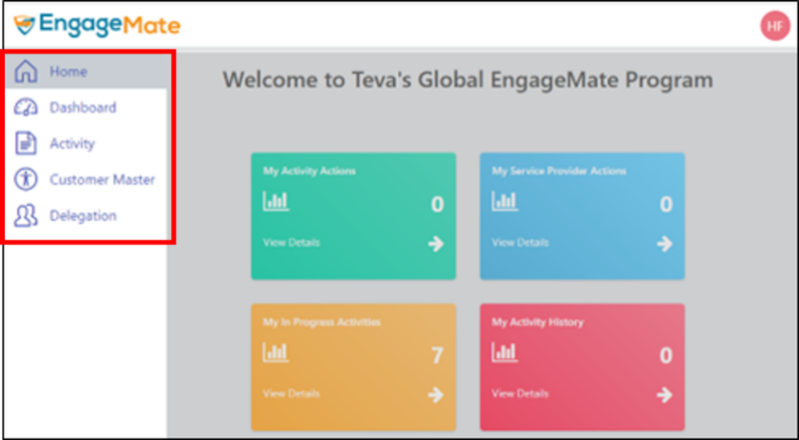
Right Hand Navigation:  Click/Tap on your initials to view your profile information.  To change user language preference is now located here. | 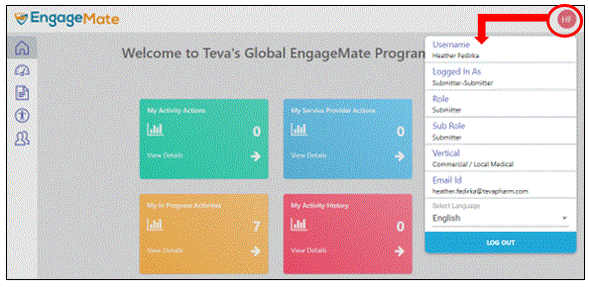

iPad Users (New Action Button View)
Action Items:  You will now need to tap on the text field "Actions" to display the available action items such as; Submit, Save, Exit, Request More Information, Reject and Approve. | 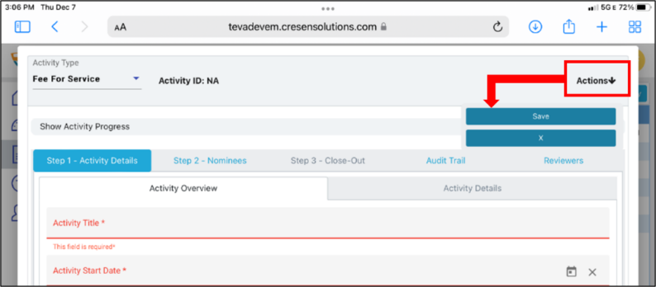
 | 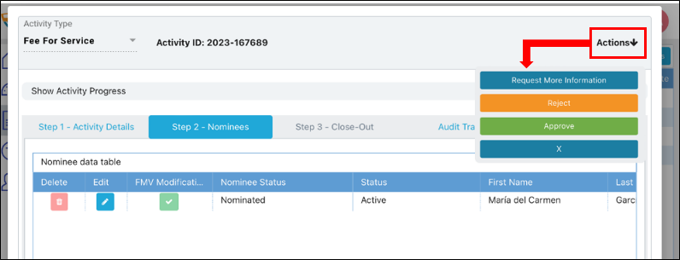

Please consult your local Compliance Officer with any questions this enhancement may have on local policy/procedures.

Visit: EngageMate’s Resource Center for useful system content such as training tutorials and quick reference cards.

Contact: ComplianceOperations@tevapharm.com for system related questions.



